Name : Parthib Kumar Das , Enrollment No: 12023052002018 , CSE , Roll No: 18

Institute of Engineering & Management, Kolkata

Email ID: PARTHIBKUMAR.DAS2023@iem.edu.in

Dasparthib111@gmail.com

Video Demonstration Link : https://www.loom.com/share/2214052a281d40c88c8ea59d2a89a349

Module Name : Python BDD Restful Automations

Experiment Title : Locate the Left-Hand Side Text Box

Problem Statement
To identify and locate the left-hand side text box on the Text Compare website using Selenium WebDriver and an appropriate locator strategy.

Objective
To learn how to locate a specific web element based on its position and interact with it using Selenium.

Tools, Software, and Concepts Used
- Python 3.x
- Selenium (latest version)
- Google Chrome
- Selenium WebDriver
- VS Code / PyCharm
- Python packages:
  - selenium
  - webdriver-manager
- Concepts: Web Element Identification, XPath, CSS Selector, Textarea, Relative Locators
Selenium supports standard locators including XPath, CSS selector, ID, class name, and tag name.

Source Code / Implementation
For this page, the two comparison boxes are text areas. The following code identifies the first/left-hand text box using textarea[0].

from selenium import webdriver

from selenium.webdriver.chrome.service import Service

from selenium.webdriver.common.by import By

from webdriver_manager.chrome import ChromeDriverManager

import time

service = Service(ChromeDriverManager().install())

driver = webdriver.Chrome(service=service)

driver.get("https://text-compare.com/")

driver.maximize_window()

time.sleep(3)

# Locate the left-hand side text box

text_boxes = driver.find_elements(By.TAG_NAME, "textarea")

left_box = text_boxes[0]

# Click the left text box

left_box.click()

left_box.send_keys("This is the left-hand side text box.")

print("Left-hand side text box located successfully.")

time.sleep(3)

driver.quit()
Output with clearly labelled screenshots :

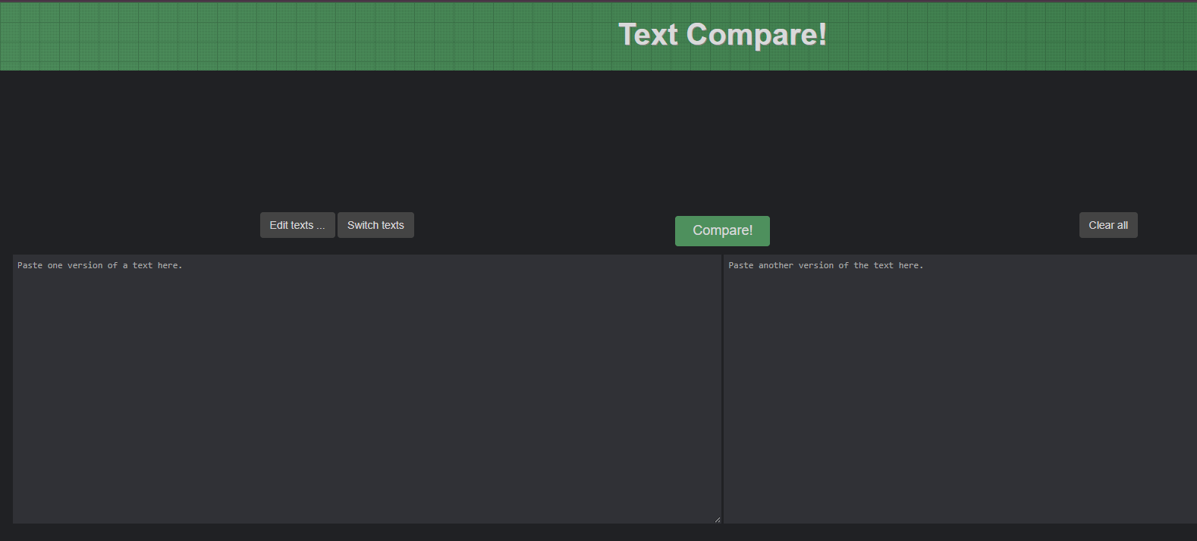
Result: The left-hand side text box was successfully located and accessed using Selenium.
Observation: find_elements() returns multiple matching elements, and the first element can be accessed using index 0.
Conclusion: The experiment demonstrated how Selenium can identify a specific web element among multiple similar elements and interact with it.

Experiment Title : Drag and Drop Using Automation

Problem Statement
To identify a draggable web element and a drop target on a webpage and perform a drag-and-drop operation using Selenium WebDriver.

Objective
To learn how to automate drag-and-drop operations using Selenium's ActionChains class.

Tools, Software, and Concepts Used
- Python 3.x
- Selenium (latest version)
- Google Chrome
- Selenium WebDriver
- VS Code / PyCharm
- Python packages:
  - selenium
  - webdriver-manager
- Concepts: Drag and Drop, ActionChains, Web Element Identification, drag_and_drop()
The given website has a Drag and Drop section with "Drag me to my target" and "Drop here" elements.

Source Code / Implementation :

from selenium import webdriver

from selenium.webdriver.chrome.service import Service

from selenium.webdriver.common.by import By

from selenium.webdriver.common.action_chains import ActionChains

from webdriver_manager.chrome import ChromeDriverManager

import time

service = Service(ChromeDriverManager().install())

driver = webdriver.Chrome(service=service)

driver.get("https://testautomationpractice.blogspot.com/")

driver.maximize_window()

time.sleep(3)

source = driver.find_element(

By.XPATH, "//div[contains(text(),'Drag me to my target')]")

target = driver.find_element(

By.XPATH, "//div[contains(text(),'Drop here')]")

actions = ActionChains(driver)

actions.drag_and_drop(source, target).perform()

time.sleep(3)

print("Drag and drop operation completed successfully.")

driver.quit()
Result: The draggable element was successfully moved and dropped onto the target area.
Observation: Selenium's ActionChains class can simulate mouse-based actions such as drag and drop.
Conclusion: The experiment demonstrated how to automate drag-and-drop interactions using Selenium WebDriver and ActionChains.
Available next action: Create a downloadable DOCX file here in this chat containing the editable prose above

Experiment Title : Write Text in the Box

Problem Statement
To identify a text input box on a webpage and enter the required text into it automatically using Selenium WebDriver.

Objective
To learn how to locate a text box and enter text using Selenium's send_keys() method.

Tools, Software, and Concepts Used
- Python 3.x
- Selenium (latest version)
- Google Chrome
- Selenium WebDriver
- VS Code / PyCharm
- Python packages:
  - selenium
  - webdriver-manager
- Concepts: Web Element Identification, Text Box, send_keys(), XPath, CSS Selector

Source Code / Implementation :

from selenium import webdriver

from selenium.webdriver.chrome.service import Service

from selenium.webdriver.common.by import By

from webdriver_manager.chrome import ChromeDriverManager

import time

service = Service(ChromeDriverManager().install())

driver = webdriver.Chrome(service=service)

driver.get("https://testautomationpractice.blogspot.com/")

driver.maximize_window()

time.sleep(3)

name_box = driver.find_element(By.ID, "name")

name_box.send_keys("Parthib Kumar Das")

print("Text entered successfully.")

time.sleep(3)

driver.quit()
Output with clearly labelled screenshots :
Result: The required text was successfully entered into the text box.
Observation: The send_keys() method is used to enter text into input fields.
Conclusion: The experiment demonstrated how Selenium can locate a text box and automatically enter text into it.
Available next action: Create a downloadable DOCX file here in this chat containing the editable prose above

